Contacts Application Design

Contacts Application Design 1
1. Overview 2
1.1. Function Description 2
1.2. Note description 2
1.3. Features 2
2. Interface Design 4
2.1. Contact Interface Design 4
2.1.1 Detaile Descrption 5
2.2. Detail View Mode 5
2.3. Edit Mode 6
2.4. Group Membership Mode 7
2.5. History Mode 8
3. Module Design 10
3.1. module description 10
3.2. Interact with other module 10

Overview
This article defines the function of the contact application，and the contacts application is the central location to store all address related information.The primary function of this part should be as follow:
  - Function Description
- Show contacts－ displays all contacts
- Edit contact－ edit the contact which you want
- Add contact－ add the contact which you want
- Delete contact－ delete contact which you want
- Serarch contact－ displays all contacts matching current search string
- Mode history－ shows a list of communication history which current selected contact
- Mode groups－ shows list of all groups which current contact's membership.
- Import contact－ import contact from

  - Note description

- Contact’s information：name,cell phone,image,mobile,email,work home
- We should take into account some limit condition when edit contact’s information,such as the length of character.
- The userId is used distinguishing from other records when add contact.
- The kind of groups: relative, colleague and so on.
- The contact API should give us.

  - Features
- add a few contacts which have on paper
- add a few contacts from PC
- call an existing contact
- correct the address of an existing contact

  - Flow For Function

This image is used for the primary function of contact

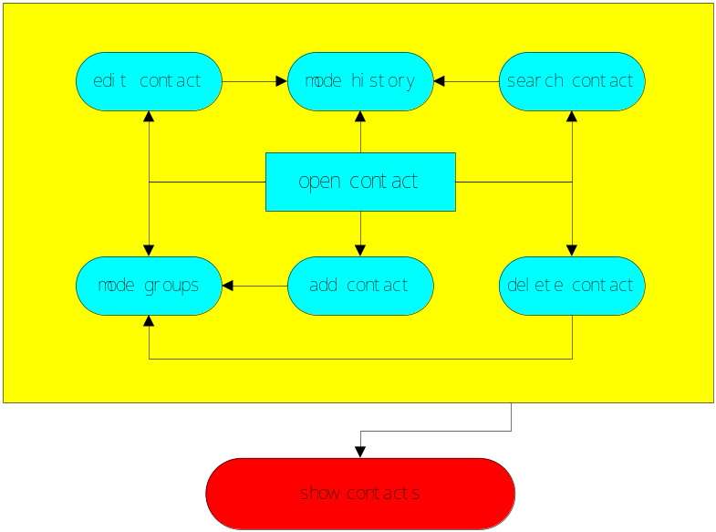
contact primary function

Interface Design
This model theme is given to us,and we have not any idea for this interface as yet,but I think we will imitate this interface which given to us.
  - Contact Interface Design
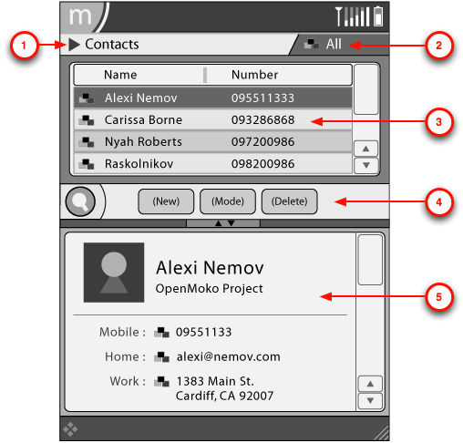
contact interface design
- Application Menu -- Additional options related to contact objects.
- Filter_Menu -- Filtering options for the list of contacts.
- Navigation Area -- List of contacts based on current filter.
- Toolbar -- Primary commands available to contacts.
- Details Area -- Detailed view of current selected contact.

2.1.1 Detaile Descrption

New
Item | Action | Constraints
New Contact | Creates a new contact called No Name | Performs no action when pressed repeatedly
New Group | Opens Dialog prompting for Group Name

Mode
Item | Action | Constraints
Mode View | Activates View Mode for Details Area
Mode Edit | Activates Edit Mode for Details Area
Mode Group Membership | Activates Group Membership Mode for Details Area
Mode History | Activates History Mode for Details Area

Delete
Item | Action | Constraints
Delete Contact | Opens Dialog prompting for confirmation | Grayed-out when zero contacts exist
Delete Group | Opens Dialog prompting for confirmation | Grayed-out when zero custom groups are defined or active group is not a custom group.

  - Detail View Mode
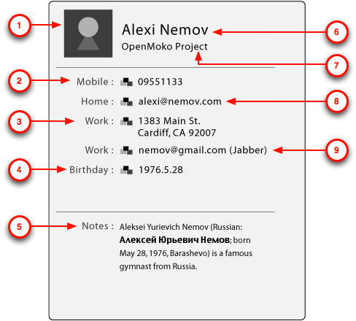
view mode
- Icon / Photo -- Photo of contact (if available) will be displayed.
- Mobile Number -- Mobile Number.
- Home Address -- Home address.
- Birthday -- Birthday.
- Notes -- Notes related to this contact.
- Name -- The contact's name.
- Company -- The contact's company name.
- Email -- Email address.
- IM -- IM address.

  - Edit Mode
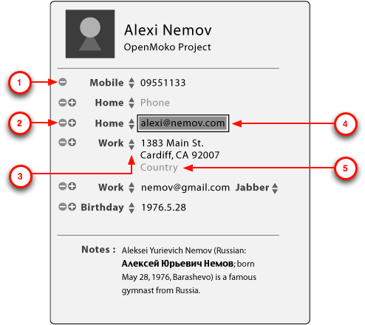
edit mode
- Remove Field -- This will empty the field contents. Empty fields will disappear in view mode. When there is only a single instance of a field it cannot be removed, so this icon will be hidden.
- Add Field -- This will duplicate the field. Some fields cannot be duplicated, such as the name or company field.
- Type Selector -- This will change the field type. The available types are defined by the field widget.
- Edit Region -- When editting a field's contents the background will visually represent this process.
- Uncomplete Field Options -- When field options are not completed they will appear in gray.

  - Group Membership Mode

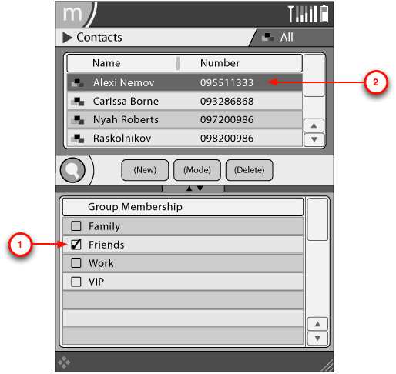
Group Membership Mode
- Membership checkbox -- When checked, the selected contact will be added to this group.
- Selected Contact -- The current selected contact.

  - History Mode
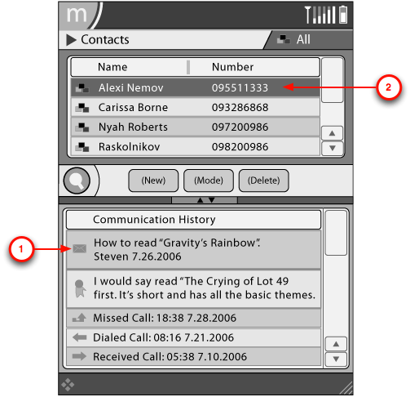
history mode
- History Entry -- History entries that related to the current selected contact. These are Preview Widgets.
- Selected Contact -- The current selected contact.

Module Design
  - module description
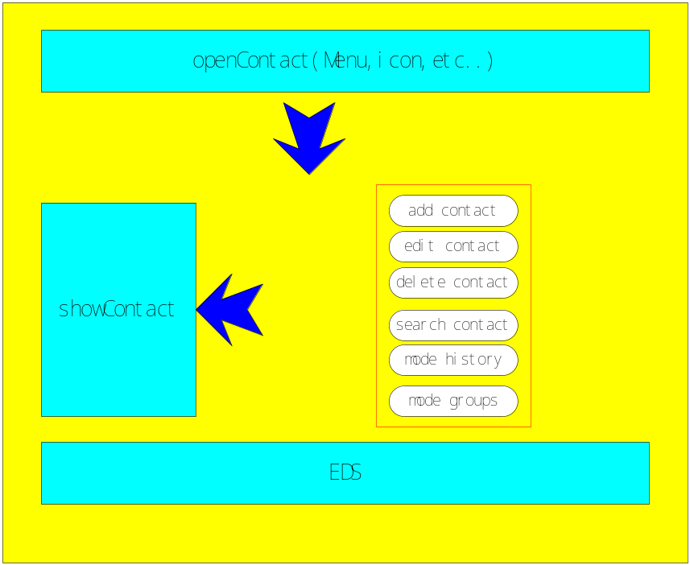
module descripition

The contact application can be launched as follow：
- Main menu
- The contact icon
  - Interact with other module
The contact application will interact with dialer module,callhandler module,message module,and in fact：most of module will interact with this application,now we find these module only,and we will supply external interface for these modules which need to use this application.
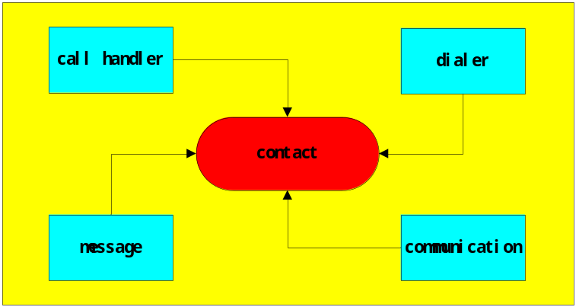
interact with other module

- Interface Design
type | explain
Data type | gchar char  gint int  GSList list
variable | id userId  name userName  cell phone userPhone  image userImage  mobile userMobile  email userEmail  home userHome  work userWork

  - contact_set_data
set contact information data such as name,phone,the path of image,
mobile,email,home,work and so on.

  - contact_add
add a new contact information.

  - contact_update
update contact information

  - contact_delete
delete a contact information

  - contact_search_name
search a/some contact information which matching given nameString

  - contact_search_group
search a/some contact information which matching given groupString

  - contact_search_history
search a/some contact information which have communicated with you

  - contact_get_All
return all contacts information

  - contact_clear
delete all contacts information

  - contact_add
add a new contact information.

  - contact_search_name
search a/some contact information which matching given nameString

  - contact_import
import the contact list from out

  - contact_export
export the contact list from in

